ESP DCC controller. Operating manual rev 3 (boards with POM read and Loconet/ JMRI support)
PART ONE: For units equipped with Display, keyboard (DSKY) and jogwheel
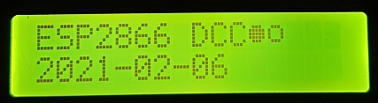 | The unit boots and shows the current software version as a date. It will then power up the track and enter loco operations mode.

Operations mode
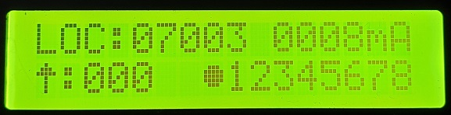 | Operate mode. Here you can control one locomotive at a time.  B-key will switch between locomotives  A-key will let you edit loco addresses, delete locos and also set 28/126 speed steps.
To select a loco from the existing roster, press B repeatedly. 8 locos are supported in the roster.
Press A to enter edit mode. Press * to toggle between 3-digit loco addresses and 5-digit addresses. Press # to will toggle 28 and 126 step speed modes. If you enter a new address by using the digit keys, then press A, the unit will create a new loco entry in the loco roster.
The unit responds with “loco created.” If it successfully creates a new entry. If there are no loco slots left, and no older locos can be bumped, then you will see a “no slots” message. A loco can only be bumped if it is stationary and is not currently under WiThrottle control.
To delete a loco, enter 000 or 00000 as the address and press A. You will see a ‘loco deleted’ message.
Each time the loco roster is changed, it is saved to EEPROM and also broadcast to all WiThrottles.
You may also abort your edit by pressing B. This will take you to loco operate mode.
 | In loco operate mode  *-key to increase speed  0-key to decease speed  *0 together will emergency stop that loco.  #-key will reverse direction if speed is zero.  D-key will toggle headlamp on/off aka F0.  1-9 keys will toggle F1 to F9  A-key will enter edit mode  B-key will select next loco/ abort edit  C-key will toggle “shunter” mode
In operate mode, you can set the speed of one loco, then select another and set its speed and so on. The red emergency stop button comes in handy if you lose track of your locos and need to hit the panic button. The red emergency stop button will send eStop to all locos. It will not turn off track power.
Pressing C will toggle shunter mode. This is indicated by a solid arrow head for direction. In this mode, decreasing speed takes you down through zero, then direction is automatically reversed and the speed will increase again. This is useful for shunting because it saves you having to enter a direction change command.
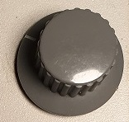 | In operate mode you can also rotate the jogwheel CW or CCW to increase/decrease speed. If you press the jogwheel down, the loco will brake. Its speed will be reduced by 30% whilst you are holding the button down. Best used with an inertia setting on your decoder.  If the loco is stationary and you hold the jogwheel button down for more than 2 seconds, the loco direction is reversed.  When driving with 126 speed steps, you may fast-rotate the jogwheel to have it increase/decrease speed in 5 step increments/decrements.
If shunter mode is active, the loco speed can be decreased by rotating the jogwheel say CCW. Once the speed hits zero, the direction automatically reverses and continued rotation in the same CCW direction will now cause a speed increase in the new loco direction.
With these features it is possible to drive, brake and reverse the loco solely from the jogwheel. This is a useful feature which is carried over to the turnout display.

Turnout display
When in operations mode, press mode briefly and you are taken to turnout mode. If you press and hold mode, you are taken to POM mode.
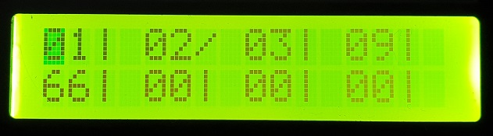 | The unit can store 8 turnouts in the turnout roster and these are kept in EEPROM. To call up a turnout, start typing its 2-digit address. E.g. 01. Once the second digit is entered, the cursor will jump to that particular turnout and blink on top of the closed/thrown indicator.

Pressing # will toggle the turnout state. Closed is indicated by a vertical line, thrown by a forward slash.
You can also quickly toggle turnouts in slots 1-4 by pressing the A, B, C or D button.
As you enter more turnouts, the least used ones are bumped. The unit supports addressing turnouts 01 to 99 through the keypad. It is possible to use the full 1 to 2047 turnout address range if you operate through the WiThrotttle. Addresses over 99 are shown in hex, and those over FF are shown as XX because they cannot be displayed in 2 digits.
Whilst in the turnout display, the jogwheel will still control the last selected locomotive. This makes shunting operations very easy. You may stay in the turnout display switching the turnouts and continue to drive a loco through the jogwheel.

Service mode (programming track)
To enter Service Mode, hit the Emergency Stop button and briefly press the Mode button.
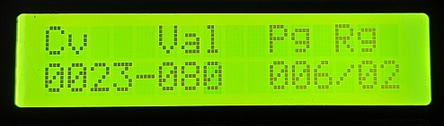 | # and * will move the cursor across the CV address and CV value.  A-key will read the CV.  B-key has no function.  C-key writes in page/register mode.  D-key writes in direct mode.
When in Service mode, the unit complies with the DCC specification and will trip if the track current exceeds 250mA.
If you have just fitted a decoder to a loco, do not put it on the main track in operations mode! First put the unit into Service mode, this sets the power to max 250mA and then place the loco on the track. Try and read CV1. This should return a value of 3. You should also hear the loco buzz/move momentarily as it energises its motor as part of the read. If this does not happen, or the power trips at 250mA or more, then your decoder is not wired correctly and you must correct this before you put it on the main track in operations mode.
This unit only has one track output. There is no separate programming track. Also Service mode is a broadcast mode so all locomotives which receive the signal will be reprogrammed. There are many DCCwiki pages available on the details of service mode.
Only byte read and byte write are supported by the unit. Bitwise operations are not supported
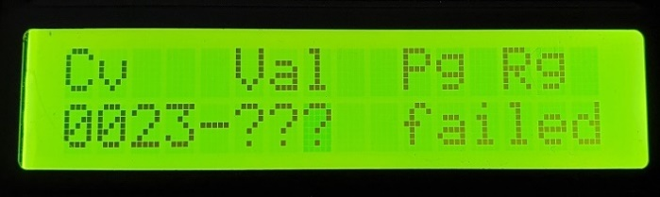 | Enter a CV and hit the A-key to read that register. If it fails to read, it is possible your decoder is wired incorrectly, or the loco is off the track or its wheels/pickups are dirty.
Hit the mode-key to exit back to operations mode.
Note: the DCC specification does not allow for driving locos when in service mode, i.e. you cannot test the loco will move forward/backward within the 250mA power limit. However, if you can read CVs successfully, then it is safe to put the loco on the track in operations mode.

POM mode (programme on the main)
POM mode is entered by long-pressing mode when in the operations mode loco display.
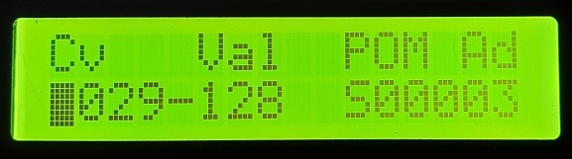 | A-key will read the CV from the loco address  B-key toggles between byte mode (shown) and bit mode  C-key has no function  D-key writes to the loco address  # and * keys navigate the cursor

POM mode reads or writes to CV registers when the loco is on the main line in operations mode. You can even write certain decoder CVs whilst the loco is in motion. Short loco addresses are denoted by S, long loco addresses by L.
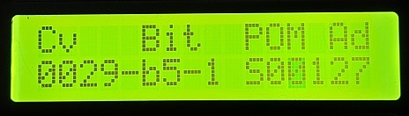 | Bitwise mode. Here you can set or clear individual bits 0 to 7 in a specific CV register.

The loco will not visibly acknowledge the byte or bit write. The loco may acknowledge over LocoNet, which is not supported by this unit. For system boards that support Railcom read, pressing A will read the content of the CV to the display.
Setting current and voltage trip
Enter this mode by pressing emergency stop and then long-press on the mode button.
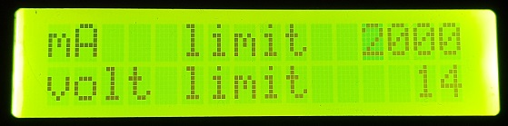 | A-key selects mA limit.  B-key selects volt limit  Mode-key exits and writes new settings to EEprom.

PART TWO: Web interface
The unit supports a web interface and this is available even if the physical Display, Keyboard (DSKY) is not present.
- The default SSID is ESP_DCC, with no password.
- The default home page is http://192.168.6.1/index.htm
- You can also navigate to http://DCC_ESP.local as the unit supports mDNS

WIFI Station mode
The unit acts as a WiFi Station by default. In this mode, laptops and mobiles must find the SSID and connect to it.

WIFI Access point mode
Software versions 2025 onward. You can set the unit to connect to your home WiFi network, i.e. act as an access point. First connect to the unit in Station mode using a laptop or mobile, then can set the SSID and password for your network on the hardware screen. You enter these as the Station address and password. The next time the unit boots, it will try to log on to your home WiFi network as set in the Station parameters. If it succeeds, it will appear on your home network at the IP address your router assigns it. You should program your router to assign the MAC address to a fixed IP, and this way your devices such as phones running engine driver have a predictable known IP to connect to when on your home net.
If the unit cannot log onto your home network (e.g. your WiFi is down, you changed the SSID or password, you move house etc.) then the unit will boot in Station mode and appear as ESP_DCC. This lets you log back into the unit and update the Station settings.

Example: connect using Microsoft Edge on a laptop
Turn on the DCC controller, use laptop to search for ESP_DCC wifi SSID (no password). Open Microsoft Edge, enter http://192.168.6.1/index.htm as the URL and you should see the home screen below.
Example: connect using a mobile phone and Engine Driver.
Turn on the DCC controller, go into your phone’s WiFi settings and chose ESP_DCC. Then open Engine Driver (Android) and set the server address to 192.168.6.1 and port 12090, click on this in your phone and Engine Driver will connect to the DCC controller (left screen below)
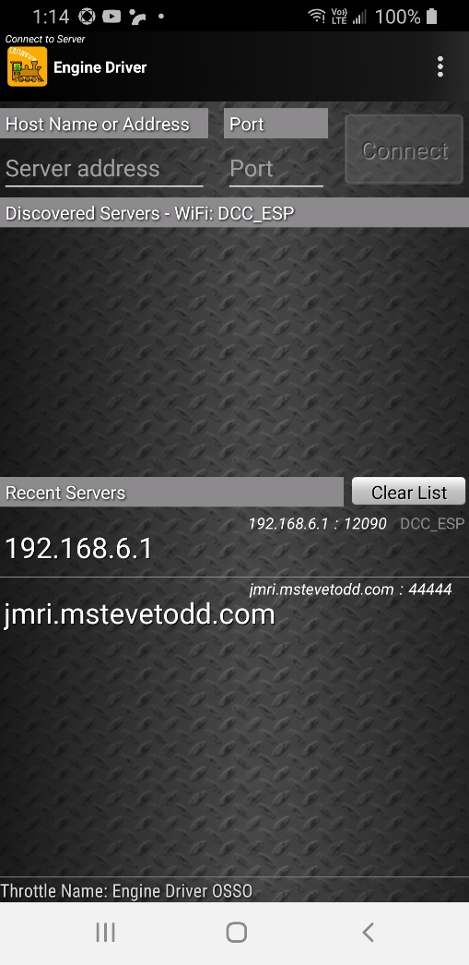 |  | 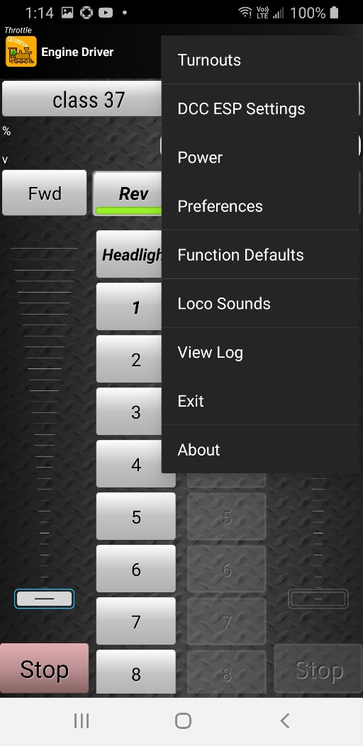

Once connected, you can open the loco roster and select a loco. You can also click on the 3-dot menu top right, and select DCC ESP settings. Under this option you will find all the web menus described on the following pages. The menu options (right hand pic) are only available after Engine Driver is able to successfully connect to the server (i.e. to the ESP DCC controller). You enter the server details top of left hand screen, namely server address 192.168.6.1 and port 12090

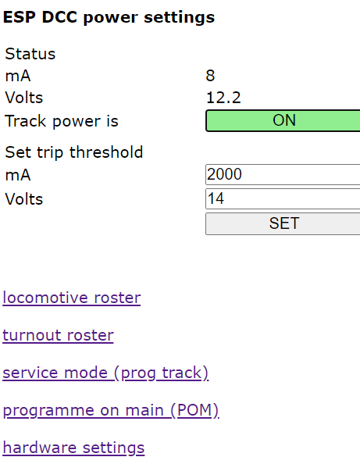 | The index.htm page is the system home page and allows you to navigate to the other web pages.  On this page you can also turn track power on/off, and also set the current and voltage trip thresholds.  Live readings of actual track power and voltage are displayed on this page.

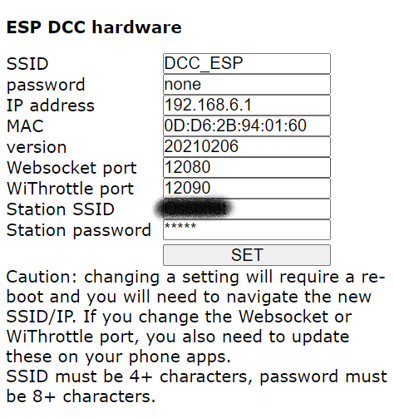 | The hardware page allows you to set the SSID and set a password when unit acts as a standalone station.  The IP address can be set. The MAC is read only.  The WiThrottle port can be changed. WiThrottle(IOS) defaults to 12090 and cannot use ports below the 10000 range. EngineDriver can use any port, but 12090 is fine.  The websocket port is used for these web pages, and never needs to change. (not until this unit supports DigiTrains as a future).  Any changes you make here will require you to reboot the unit. And obviously if you change the SSID or IP address, you will need to navigate to your new settings.  2025: Station SSID and Station password are the network settings of your home network, should you wish to connect via this. Also the default WiThrottle port is now 2560.

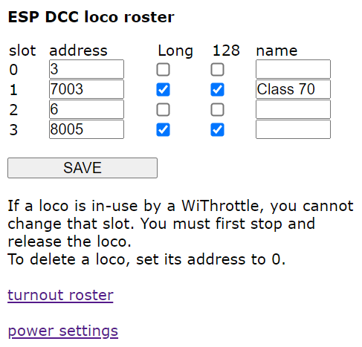 | The loco roster can support up to 8 locos. You may edit the roster entry here, and these changes will flow through to any WiThrottle controls.  If a slot is in use, i.e. the loco is moving or it is under the control of a WiThrottle, then the entry is highlighted and you cannot edit it until you zero the speed and/or release the loco in WiThrottle.  There is no support for DCC defined consists. You can create ad-hoc consists in EngineDriver.

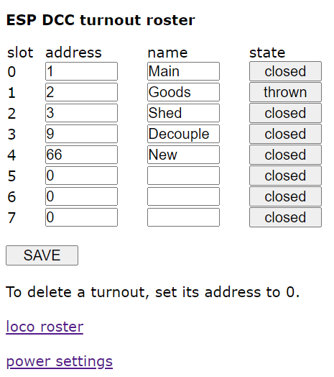 | The turnout roster can hold 8 turnouts. Routes are not supported.  You can edit the turnout address and name. Changes are pushed through to the WiThrottles. You can also toggle the turnout states from this page.  Addresses of 1-2047 are supported. This is an 11-bit schema.
Note: The DCC specification defines a 9-bit turnout schema with each address supporting 4 devices. This is quite confusing and most manufacturers use the 11-bit schema where each device effectively has its own address. DCC++ uses a 9-bit schema.
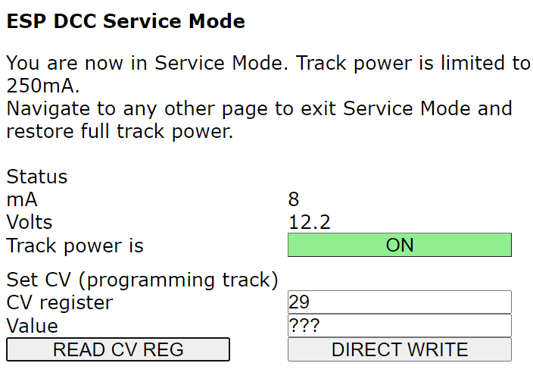 | Service Mode, aka programming track. When you enter this mode, power is limited to 250mA. You can read/write CVs.  Only direct write mode is supported, and only byte values can be read/written.  If you have installed a new decoder, do NOT put it on the track in operations mode. First set the unit on service mode, then put the loco on the track. If you can read/write CVs to it, then it is wired correctly and can be used on the main.
Important: you need to navigate away from this page to allow full power to be restored to the main.

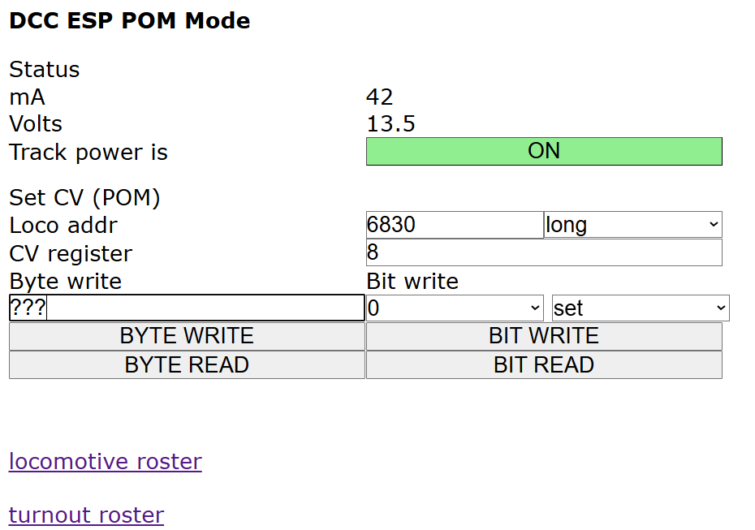 | In POM mode, you can read/write to any loco address short or long on the main line. Some decoders even support you doing this as the loco is running.  2025: If using the rev 4 blue PCB which has Railcom read support, you can also read CVs from your locos.  You can bit write or byte write.

Railcom is not supported by all decoders, but is supported by many new decoders. This system does not support automatic discovery of locos on the main.

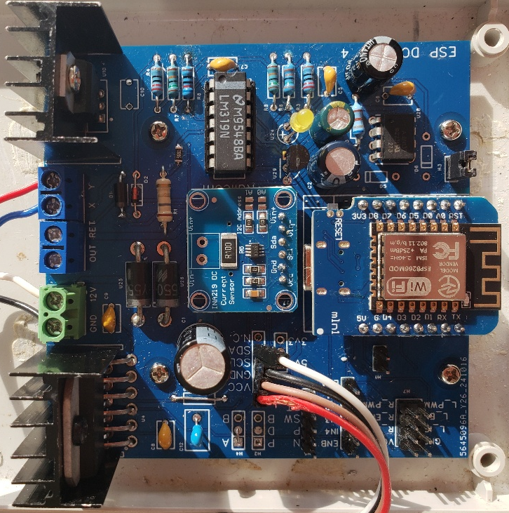
The 2025 rev4 board with Railcom read support.
Boards with software version 2025-08-xx and higher now support a jogwheel even when in WIFI only mode. If you do not fit an LCD display and keypad, you can still connect up a jogwheel and this will control the active loco as set in the “Jog” column in the DCC ESP Settings page, loco roster. The jogwheel is optional, and offers yet another way to control the speed of the loco. You will find that the loco is put into ‘shunter mode’, i.e. if you dial the speed down with the jogwheel, it will decrease through zero, cause a direction reverse and increase speed in the reverse direction.

PART THREE: Interworking with JMRI Decoder Pro and Panel Pro
A new feature of the software in 2026 is support for JMRI and Loconet.
JMRI is an opensource and free model railroad control system that runs on a laptop. It has two main modules; Decoder Pro, which manages multiple loco decoder CV parameters (via Service Mode or POM) and Panel Pro, which manages multiple turnouts and sensors. Additionally, the JMRI system can support multiple WiThrottles such as Engine Driver. I believe it is also capable of automating operations on a layout. It is very powerful and rather complex but there are a lot of good tutorials on the internet that cover how to set it up and how it works. In this manual I will only cover the basics of how to connect the DCC_ESP to JMRI and run a few simple tests.

Connect to JMRI
Your laptop running JMRI must be able to connect to the DCC_ESP. It can do this via the DCC_ESP acting as an Access Point (aka local hotspot) or via the DCC_ESP first connecting to your home Wifi.
To make life easier, the DCC_ESP supports mDNS which is a local domain name system, and this means the DCC_ESP appears at http://DCC_ESP.local (that is DCC_ESP.local) and you do not have to know its actual IP address.
Note that if the DCC_ESP fails to connect to your home WiFi after 20 seconds it will revert to acting as an Access Point and will appear as SSID DCC_ESP (unless you changed this name). This is useful if your router is turned off, you are at a friend’s house or changed your WiFi password.

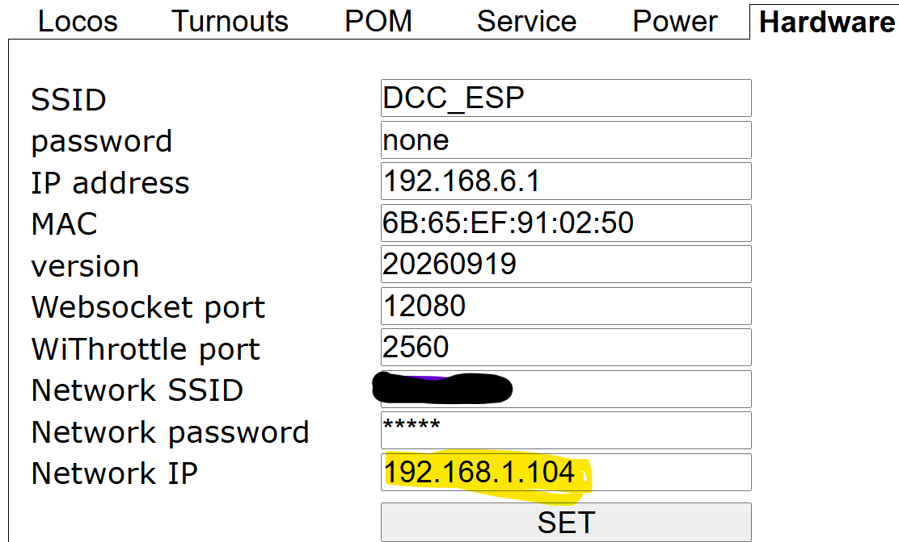 | If you need to discover what IP address your home router assigned to DCC_ESP, you can navigate to http://DCC_ESP.local and check the hardware tab. The Network IP is set by your router.

Fire up JMRI Decoder Pro on your laptop and set its connection configuration. The DCC_ESP emulates a Digitrax DCS240 running Loconet over TCP IP on the WiThrottle port number (2560 in example above) and the Network IP (or DCC_ESP.local which saves you having to know the IP).
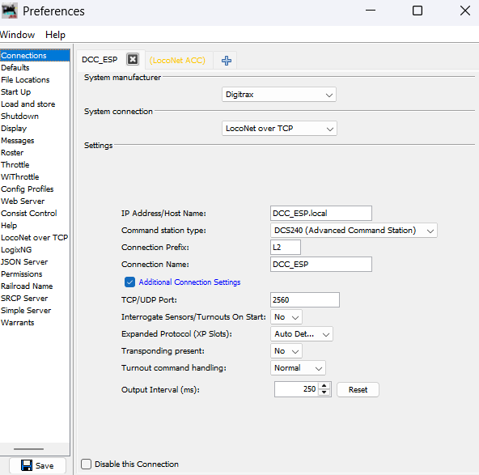 | In JMRI preferences… connections…  Select Digitrax  LocoNet over TCP  then  DCC_ESP.local (or the network IP address)  DCS240  The TCP port is 2560 or whichever port you set as the WiThrottle port on the DCC_ESP  And chose SAVE. The DCC_ESP emulates a Digitrax DCS240 controller and runs Loconet.

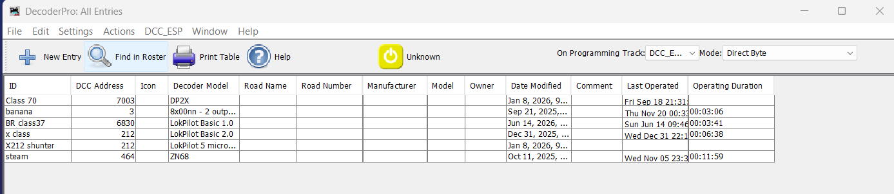
If Decoder Pro finds the DCC_ESP, it will connect and show you its current locomotive roster. You will also see one of the menu options appear as DCC_ESP. Note that Decoder Pro can hold hundreds of locomotives in its roster, you are not limited by the 8 loco limit in the DCC_ESP EEPROM. (You are limited to controlling max 8 locos simultaneously). Also note the Decoder Pro loco roster is NOT pulled from the DCC_ESP. The roster is set up by you, directly in Decoder Pro and is entirely separate to whatever roster happens to be in the DCC_ESP.

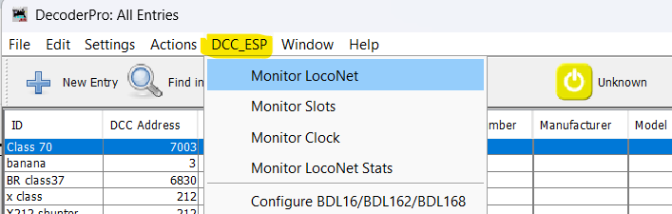 | If you invoke the ECC_ESP menu item and select Monitor LocoNet, you can see the LocoNet messages sent to/from the DCC_ESP in a pop-up window. For example if you toggle the power button (where it says Unknown above) then you will see this…

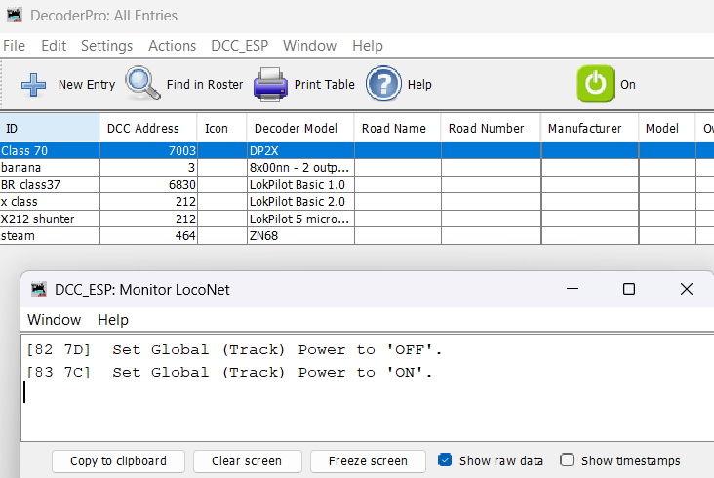 | Toggling the power button will send a Global Track power message over LocoNet to the DCC_ESP. You will see the trackpower on the DCC_ESP go off/on (as indicated by the yellow LED)

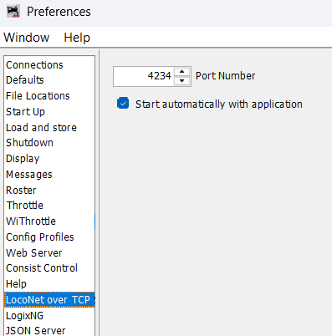 | In Decoder Pro, Edit… Preferences…  select LocoNet over TCP and set the port to 4234 and to start automatically.  This is required to communicate with ACC_ESP accessory controllers, see a future Instructables.

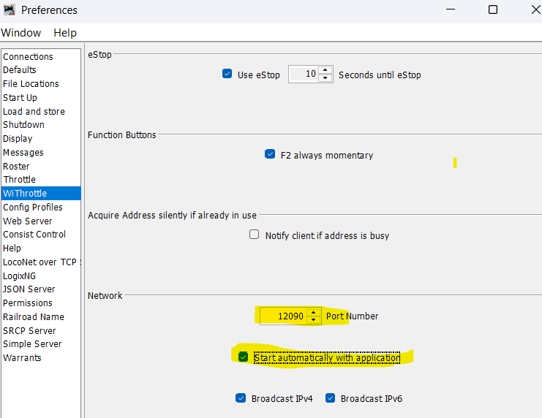 | And, also configure WiThrottle to start automatically on port 12090.  This is used by Engine Driver throttles. These need to connect to JMRI on the laptop and NOT connect directly to the DCC_ESP (because it is not operating as a stand alone device).

Reading/ writing loco CVs
In decoder pro you need to set whether you wish to use POM or Service Mode when reading/writing CVs. This is controlled from Settings… Programming Type…
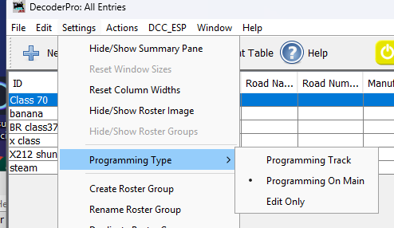
If you select Programming Track (aka Service Mode) you will find that you can read/write “sheets” from the programming window.
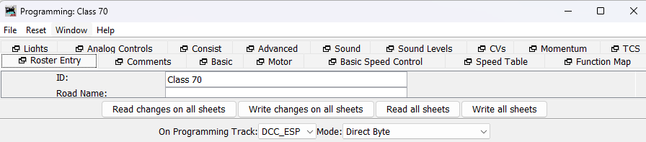
Note: sending Programming Track commands to the DCC_ESP controller will put it into low power 250mA mode (aka Service Mode). To exit this mode, you need to close the programming window and then cycle the track power off-on. You cannot drive a loco during Service Mode. This is by-design and part of the DCC specification.

If you select Programming on Main, you will find that you can only write “sheets”. This is a limitation / oversight of the JMRI software. It should provide a means to read all sheets via the Railcom protocol. Perhaps this will be addressed in a future release.
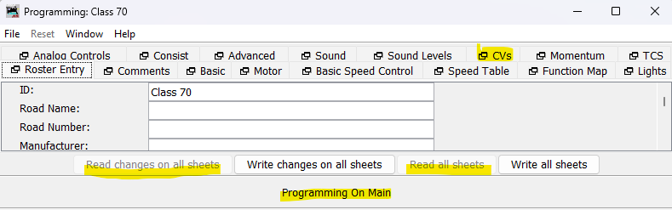
The workaround is to select the CVs tab, and manually click Read for each CV in turn.
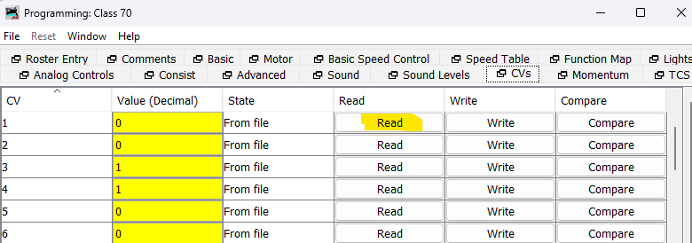

- End -

For revised hardware boards, rev 4 blue PCB with Railcom read support

